Sign in to SystmOnline:
- Via browser on – https://systmonline.tpp-uk.com/
- Via app downloaded from Google Play store or Apple App Store

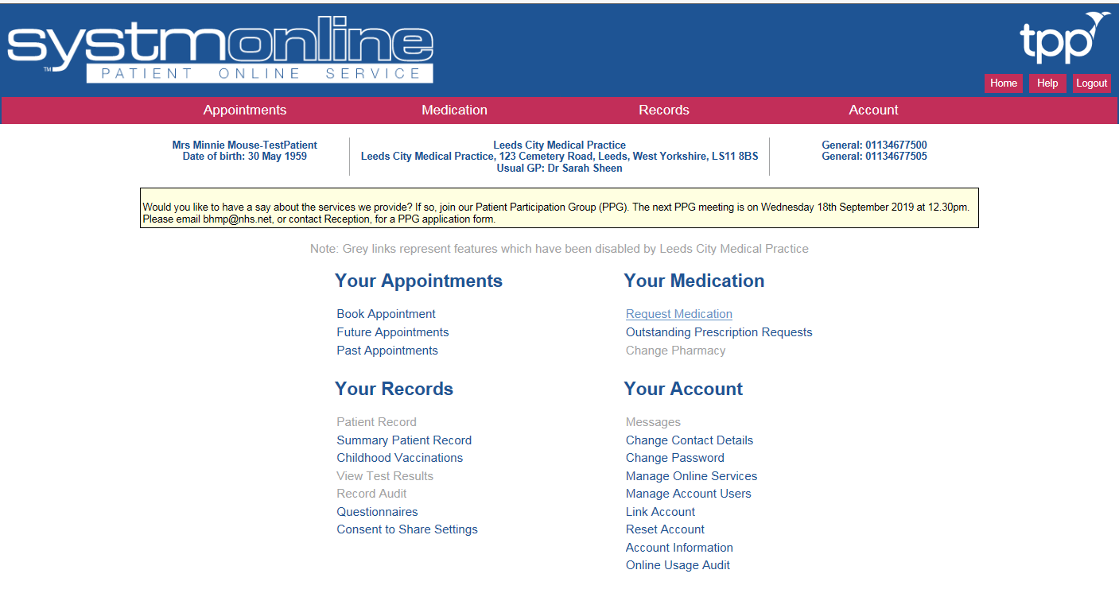
On the home screen, single left click Request Medication.

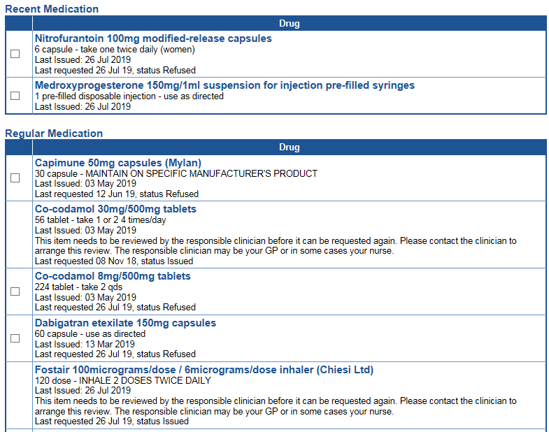
Any medications that are due will have a tick box to their left. Repeat medications will appear in “Regular Medication” and Acute medications will appear in “Recent Medication” if they have been issued in the last 6 months.
Tick Box
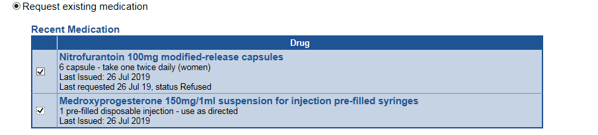
To request an item single left click the tick box and a tick will appear in it.

Once you have selected all items you need single left click “Continue” at the bottom of the screen
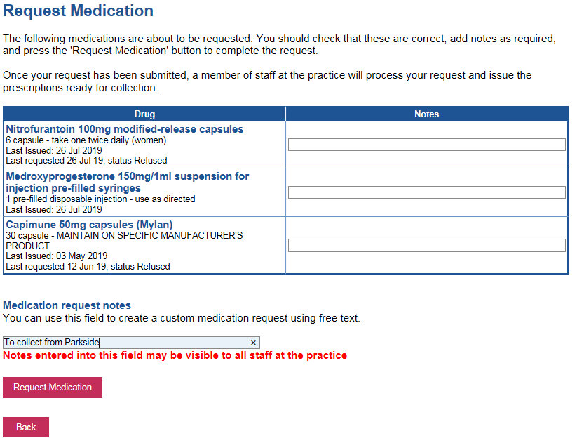
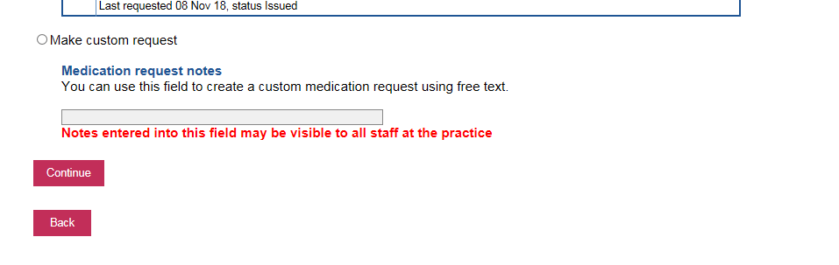
On the next screen if you would like to leave a note for the staff member dealing with your request please do so in the box provided (this can be things like I would like to collect from Beeston Hill/Parkside site, or send to chemist). Once complete single left click “Request Medication”
This will now be sent to the surgery to deal with. You can request medication up to 7 days before it is due – however we require 2 working days to process, sign and/or send the medication to a chemist ready for collection.

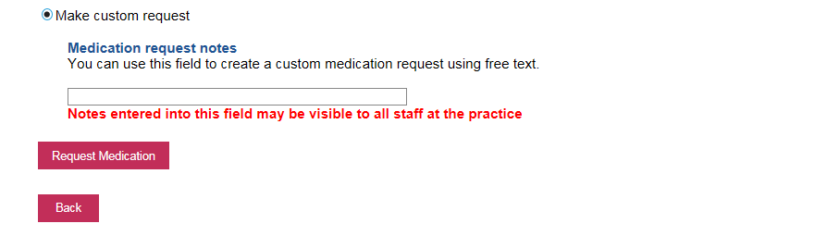
If the medication is not on your list online (ie it has not been requested in over 6 months, or it is not on your repeat) you can use a Custom Request. This is located at the bottom of the medication screen. Single left click the circle next to “Make custom request”.
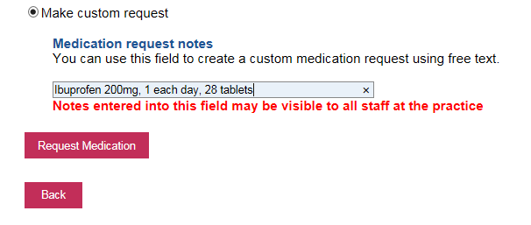
You can now type in your medication request in the box – please specify the name of the medication, the dosage and the quantity. These requests will then be sent to the GP and either issued or a member of the reception team will contact you with details of what to do next. Once complete single left click “Request Medication”

